**How will PE & Health and Wellbeing be implemented?**

A clear and comprehensive scheme of work in line with the National Curriculum supported by Twinkl PE as a guide for sequencing and progression. **Within P.E lessons, children will adopt many different roles such as a performer, coach, umpire and leader and explore many different indoor and outdoor, individual and team activities.**

* **PE Kit**

*Children have access to a PE Kit that can be purchased at school.*

* ***Access to experts***

*Over the period of the year each key stage children will have opportunities to work with PE experts from outside of the school, including the Poltair School PE Partnership.*

* ***Inter Events***

*Children will have access to competing against pupils from other schools.*

* ***Inter-school Events***

*Pupils from all phases get the opportunity to attend events run by Cornwall School Games and the Mid-Cornwall Sport Network.*

* **Displays**

*Display in school Hall will celebrate involvement in PE and healthy lifestyle tips.*

* ***Clubs***

*Children will have access to PE-based and healthy lifestyle clubs, such as multi-skills, nerf wars and gardening, outside of the school day. Girls only clubs have also been implemented to promote sport for all.*

* ***Cross Curricular links***

*The Twinkl curriculum makes links with other subjects including Geography, Science, PSHE and Maths.*

* ***Swimming***

*All children from year 1-6 will be supplied with swimming lesson by professional coaches at the local leisure centre.*

* ***Healthy Living Week***

*Annually the school celebrates ‘Healthy Living Week’ to educate and promote a healthy lifestyle and physical activity.*

**What do we want for our pupils?**

At BB we understand how vital it is to encourage the children to lead a healthy lifestyle, as well as informing them of ways in which to do this and why it is so crucial to maintain this throughout their lives.

It is our intent to build a PE & Health and Wellbeing curriculum that **that encourages and provides opportunities for all children to lead healthy, active lives whilst** developing their competence to excel in a broad range of physical activities which results in them knowing more, remembering more and understanding how the knowledge and skills can be applied in their own physical activity and healthy lifestyle.

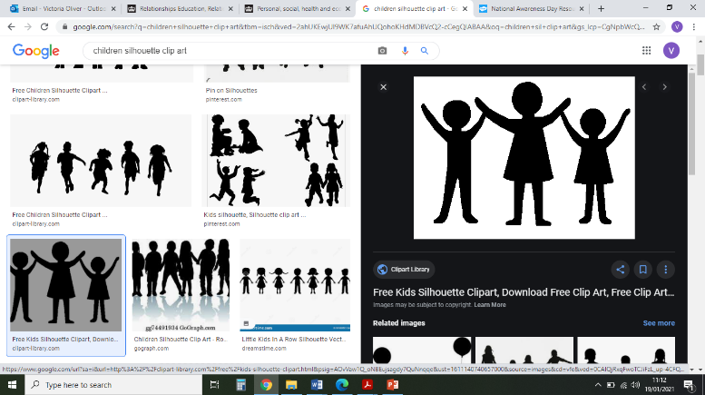

**How will PE & Health and Wellbeing impact pupils?**

At BB, we ensure that our PE curriculum is progressive and allows children to develop fundamental skills and apply them to a variety of sports and activities. All children are provided with the skills and given opportunities to demonstrate improvement to achieve their personal best. Our pupils are physically active and this has positive implications on their learning in the classroom. Children understand how to lead a healthy lifestyle and understand the importance of, not only exercise, but of keeping a healthy mind and well balanced diet.  We hope children enjoy PE and develop a love of sport and physical activity that they pursue outside of school and in future life outside of primary school. All pupils understand the values and importance of fair play and being a good sportsperson. Year 6 pupils leave school with the skills to self-rescue in the water and swim 25 metres competently.

**PE & Health and Wellbeing**