
Bishop Bronescombe C of E (VA) School
'Learning that lasts a lifetime.'

Policy for Collective Worship
Due for Review:  July 2025 | July 2023 | Written by  Revised by:  Governor responsible: | Beth Horwell  Wendy Williams

School Vision:

The vision of our school is ‘We share our gifts and talents, and with God’s help, it can become something amazing!’

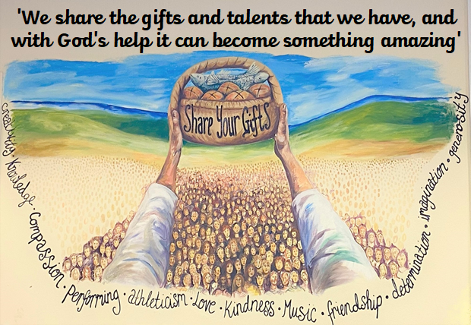

Collective worship forms that part of the whole curriculum designed to promote the spiritual and moral development of the children in a shared experience of celebration, praise, reflection and thanksgiving to God in accordance with Education Reform Act (1988), the Trust Deed of the School and the recommendations of the Truro Diocesan Board of Education. Within our Collective worships, we encourage children to share their gifts and talents, with God’s help, we hope to see amazing things happen because of this.

School Aims:
Bishop Bronescombe C of E Motto is: ‘Learning that lasts a lifetime’
Rainbow Multi-Academy Trust’s Mission Statement is: ‘Building a brighter future together.’

General policy statement:
All staff, governors, volunteer helpers, students and visitors need to give due regard to all of the policies and practices adopted by the school. Whilst it is acknowledged that people other than staff cannot be expected to read every policy before a visit to the school, it may be that further guidelines are necessary in addition to the Visitor policy, which all visitors must acknowledge and accept upon arrival. All staff carry responsibility for the welfare and success of the children in our school. Staff will advise anyone who is working alongside us of the necessary protocols, procedures and policies we follow.

Living out our vision during collective worship

Collective Worship in our school is a highly valued time which is a specially set apart time in the school day. The whole school community gather together in a time that is honouring and worthy to God. The planning of our Collective Worship ensures that the school community has the opportunity to arrive for worship prepared with the right attitude, engage with their own spirituality and learn from Biblical teachings and leave feeling refreshed and inspired.

Our school vision ‘We share the gifts and talents that we have, and with God’s help, this can become something amazing!’ is lived out through our collective worships. Children are encouraged to share their gifts and talents through singing, performing, their reflections and celebrating each other’s achievements. The collective worship team are also enabled to share their gifts and talents by being supported to plan and deliver collective worships to the rest of the school.

As a school, we focus on 6 Christian values, these are: compassion, courage, forgiveness, respect, trust and perseverance. These values are a focal point for our collective worships throughout the year, but we also focus on the church year and other events within our collective worships.

Aims of Collective worship
- To give children the opportunities for looking at issues within our world and give them time and space to be able to reflect on what they have heard and think about how it makes them feel
- To encourage children's natural sense of wonder of God and his creation and to develop their qualities of curiosity, celebration, gratitude and awe, which form the foundation of worship.
- To offer children an opportunity to develop their spirituality and relationship with God and express their concern for others and the world through prayer and worship.
- To enable the overall personality and ethos of the school to come across to everyone.
- To create an opportunity to share and reinforce the values the school seeks to live by.
- To foster a spirit of community in the school.
- To express praise and thanksgiving to God together
- Share each other’s joys and challenges through valuing all God’s children

Guidelines
An Act of Worship will take place each day. Sometimes this will involve the whole school, but on some days separate acts of Worship will be held for KS1 and KS2 children.

The worship will be ‘Inclusive, invitational and inspiring’ as stated in the Church of England’s Collective worship guidance.

The worship will be planned to be relevant, meaningful and inclusive of all ages, abilities and backgrounds. It will allow for a variety of responses, from awareness and appreciation through respect and commitment to devotion and adoration.

Acts of Worship will reflect the ethos of the school and help children to understand its' spiritual, moral and cultural values.

The acts of Worship will be led by Staff, Deanery Clergy, the collective worship team or by carefully chosen visitors.
Worship will be shared, when appropriate e.g. Christmas, with the wider Church Family, especially with those who worship at St. Luke’s.

Worship will also take account of the major festivals of the Church year and with the curriculum plan of the school year.

The act of Worship will follow a recognisable format.
- The worship should last approximately 15 mins from 1.15 – 1.30pm
- The collective worship team will have set up the reflective space
- The act of worship will be started by lighting a candle and the person saying “We light this candle in the name of God the Father, God the Son and God the Holy Spirit.”
- There will be songs in appropriate places, which will, whenever possible, relate to the theme of the worship.
- There will be a quiet time for reflection, sitting or prayer. Prayers may be taken from a variety of resources including teachers own resources or children's own work. Regular use of the Lord's Prayer whether said or sung.
- The worship will have a clear focus and will often involve pupil participation.
- Elements used in the worship may include music (ising, C.D.s), listening to stories, bible readings and other relevant passages, drama, artefacts, and other material may be used.
- Opportunities for stillness, silence and reflective prayer should be offered to think about the key thoughts and the Bible message.
- At least once a term Communion Services will be held for all year Groups, but led only by children from Years 3 - 6. An additional Leaver's Communion will be held at the end of the Summer Term. All parents and friends will be invited to join us at our Communion Services.
- All worship should end with a thought or a question for children to ponder, to encourage them to act following the worship session.
- The act of Worship will be closed by the candle being blown out, the person leading worship will say “God be with you.” And the pupils respond “And also with you.”
- Any notices will be clearly separated from the act of Worship.
- Collective Worship will be monitored by the RE Lead, Head of School, Collective Worship Governor and Collective worship team

The Education Reform Act 1988 makes provision for pupils and teachers to withdraw from Collective Worship. Parents wishing to exercise this right are asked to express their wish in writing to the Head of School.

Conclusion
The daily collective worship needs to be meaningful and valuable; it should create a sense of belonging. If it is carefully planned and encompasses the guidelines defined it will form a spiritual experience for pupils and staff which is central to the ethos and fundamental aims of the school. It will offer experience of worship and offer time for spiritual reflection. It will be where teachers and pupils may express joy and thankfulness, share concerns and experiences, affirm the beliefs and values of the school community and the Christian Church of which they are a part.

How our collective worship is Invitational, inclusive and inspiring

Invitational | Inclusive | Inspiring
All children are invited to worship through the lighting of the candle. Leader: We light this candle…  Response: In the name of God the Father, God the Son and God the Holy Spirit | The whole school community gathers together for collective worship four days a week. Collective worship as a class is once a week | At the end of each collective worship, children are challenged to ‘make a difference’ or ‘make a change’ based on what they have heard.
During prayers, children are invited to end the prayer by saying Amen, to make the prayer their own. | The content of collective worship is considered carefully to ensure all children receive their right to engage in worship that is appropriate to them. | Inspirational stories of Christians who have made a difference in the real world are included in the planning of Collective worship.
During reflection time and moments of stillness, children are invited to close their eyes and be calm to think. | A range of styles is planned into the timetable to ensure all are able to access ad engage in the worship. Styles such as, artwork stimuli, music, multimedia, drama, prayer and stillness, story, sung and reflection time. | During each collective worship we have reflection questions, these are designed to engage the children, to make them think, and to be inspired by the teachings of Jesus.
During Open the Book collective worships, and collective worships that visitors lead, children are often invited to help lead parts of the worship. | Sentence stems are included in collective worships to enable children to be able to participate and share their thoughts. | Worship follows four clear parts: To gather, to engage, to respond and to send out. This is to inspire and set the purpose for each element of worship
Children are invited to sung worship through appropriate song and prayer choices. | During class collective worships, children are encouraged to share their reflections, using the reflection area and by sharing them in the collective worship reflections book. | The Worship Team deliver collective worship once a half term. To become part of the worship team, children need to be role models who display our Christian values. Children aspire to become like the collective worship team.
Children are often invited to share their input and reflections when ‘Big questions’ are asked as part of the collective worship | The length of worship considers the age of the children, sensory needs and need for prompts to ensure understanding and ability to engage in the worship. | Children’s interests are taken into account when collective worship is planned, to ensure that it will be inspiring. Video clips are often used to inspire pupils. i.e. Derek Redmond – perseverance, Dick and Rick Hoyt – compassion and perseverance
Parents are invited to our termly communion services and are invited to take the bread and the wine if they have a relationship with God

